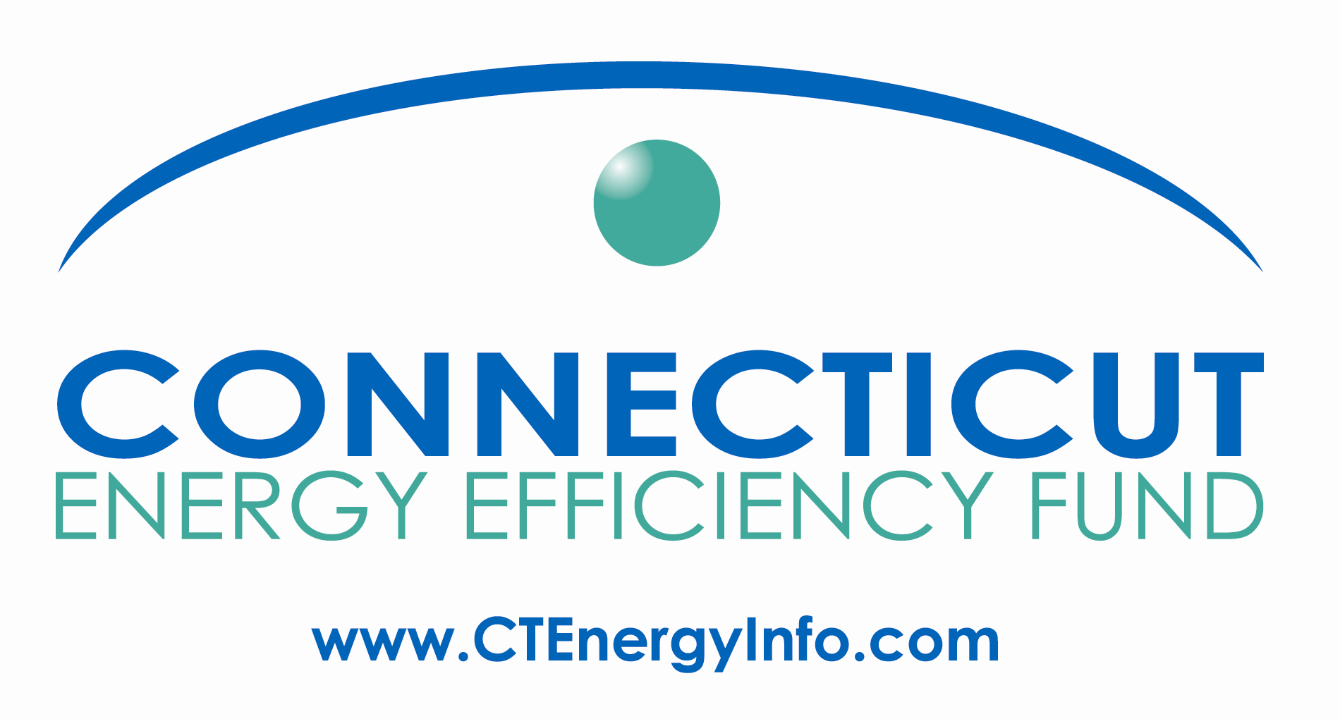

Agenda

Energy Efficiency Board
Residential/Home Energy Solutions Committee Meeting
January 19, 2011, 9:30 am - 12:00 Noon
Department of Public Utility Control
10 Franklin Square, New Britain, CT 06051

Call-in #: 800-655-1109 Pass code: 8758697
9:00
- DPUC Final Decision On 2011 Electric C&LM Plan
  - See accompanying summary of residential orders and discussion
- Residential Financing update
  - Pilot status
- Process and timeline to establish procedures to provide third parties customer data
  - Current status of Company efforts
  - Unresolved issues: next steps, who is responsible and completion dates
- eeCommunities update, including coordination with CCEF and other community programs
  - Status of Tool Kit and website
- Addressing 2011 Program “Roll Out” Questions: Assign dates for their completion
- OPower
  - Update on Program status
  - How is OPower being used to drive participants to other CEEF programs?
- Other

10:50 Break

11:00
- Public Input
- HES
- Additional vendor comments/questions on Department decision
- Other vendor questions/concerns

